Step 1:

Ping the agent in cmd and get the ip address

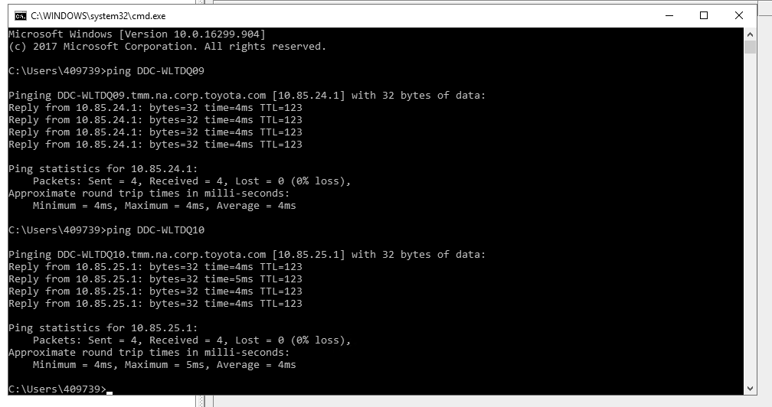

Step 2:

Go to bin directory in JMeter and open JMeter.properties file using Notepad

apache-jmeter-2.11 -> bin -> jmeter.properties

Step 3:

Add the slave computers IP address in the “remote_hosts=xxx.x.x.x”

Note: We can add multiple IP’s by separating using the “,” operator

DDC-WLTDQ09 and DDC-WLTDQ10 ips added in host file.

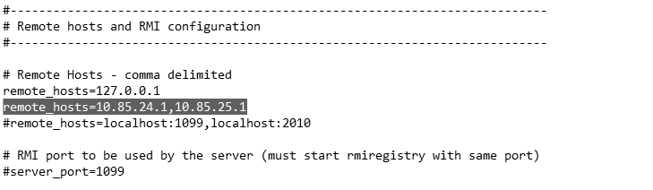

Restart the jmeter

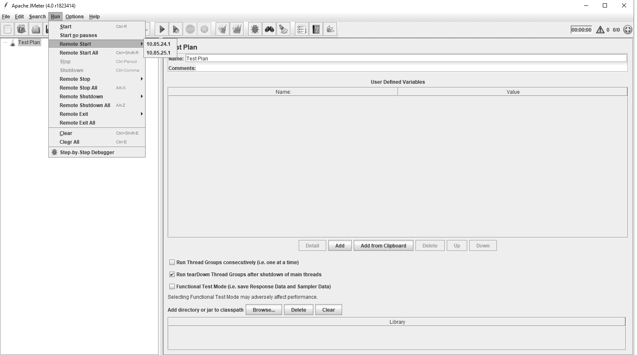

The agents got reflected then when we tried to execute the script we got error as rmi_keystore.jks is missing.

We created the rmi_keystore.jks using create-rmi-keystore which is in BIN folder.

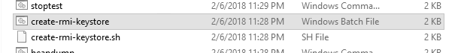

Rmi_keystore.jks has been created in bin folder .

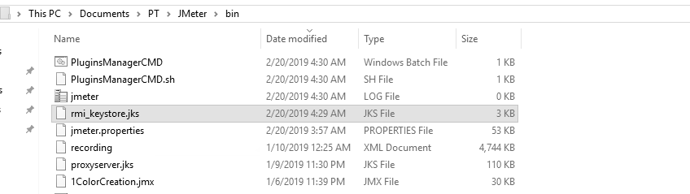

Still getting error as,

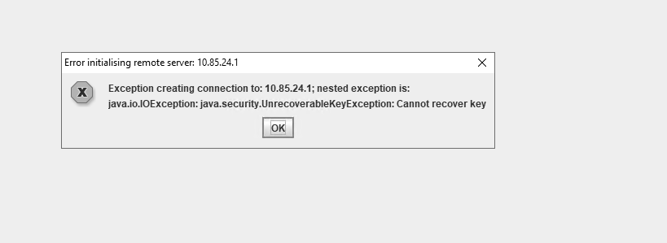

Error: "java.security.UnrecoverableKeyException: Cannot recover key"

**Cause**

The keystore password and the keyEntry password are different.  Error occurs when restarting the Jakarta engine.

Please refer the below,

https://knowledge.digicert.com/solution/SO986.html